***GROW DWARF FRUIT VARIETIES***

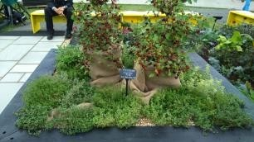 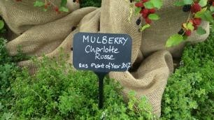

If it’s too big don’t despair – just choose a dwarf variety

Kitchen gardens have been using dwarf varieties for centuries, but their are still new crops being developed to increase the range of plants available to the small scale gardener.Mulberry Charlotte Russe is the latest example, offering a dwarf shrub (growing to about 1.5m) where other Mulberries would be well beyond the scope of most small gardens. It won the 2017 RHS Chelsea Plant of the Year award and is capable of fruiting in its first year. I have heard reports that the fruit taste is disappointing, but can’t comment as mine was devoured by the slugs in its first few weeks. It is now recovering in the greenhouse, but I’ll need to wait until next year to join the taste testing.